The Message Structure & Parser Design Document

Security Classification: | Internal
Document Reference: | N/A
Status: | Issued
Version: | 1.0
Team/Department : | Core Development\Networking
Author(s): | Petr Smrz
Owner(s): | Networking TA

Approver(s): | Networking TA | Distribution:

Contents
1 Introduction 3
1.1 Purpose and Scope 3
2 Design Overview 3
2.1 Design Goals 3
2.2 Solution 3
3 Detailed Design 4
3.1 UML 4
3.2 Behaviour 6
4 Design Considerations 7
5 People 7
5.1 References 7
5.2 Open Issues 7
5.3 Glossary 7
5.4 Document History 7
5.5 Document Review Date 7

Introduction

Purpose and Scope
This document provides an abstraction of the message structure and parser, offering a way to declare a message record over a continuous data descriptor. The document is a part of networking base used to create networking components. The target audience is members of the Networking Team developing new components or maintaining the old ones.

Design Overview

Design Goals
These are the design goals:
- Offer a tool to declare a message record so that the message structure can be clearly seen from the code
- Create a set of templates/classes the message can be constructed from
- Minimise memory usage and code redundancy

Solution
The solution is based on an assumption that the message record is placed in a continuous 8 bits descriptor in the following fashion:
Constant, the header has zero length
Variable, the header has length > 0
Big endian

Little endian

Header
Body
Item 1
Item 2
Item N

Item 1
Item 2
Item N
Static Part(declared)
Dynamic Item
Dynamic Part(created whilst parsed/initialised)
Maps to

Data descriptor

Figure 2-1 Message Record mapping assumed by the design
As the Figure 2-1 shows that the design breaks a descriptor into static part (always present) and dynamic part (sometimes present). The either part has a record of items and each item has a header. The header can be of zero length (for items of constant length) or of length > 0 for items with variable length. The header value can be placed in the descriptor in the big/little endian byte order.

Advantages:
- The message item is not copied; it is simply accessed as a part of the given descriptor.
- A message structure is declared in C++ fashion
- Unified framework to parse and compose a message’s record.

Disadvantages:
- One item of variable length takes 16 bytes memory overhead. The class TPtr8 takes only 12 bytes.

Detailed Design
This section gives a detail insight into how the classes co-operate with each other.

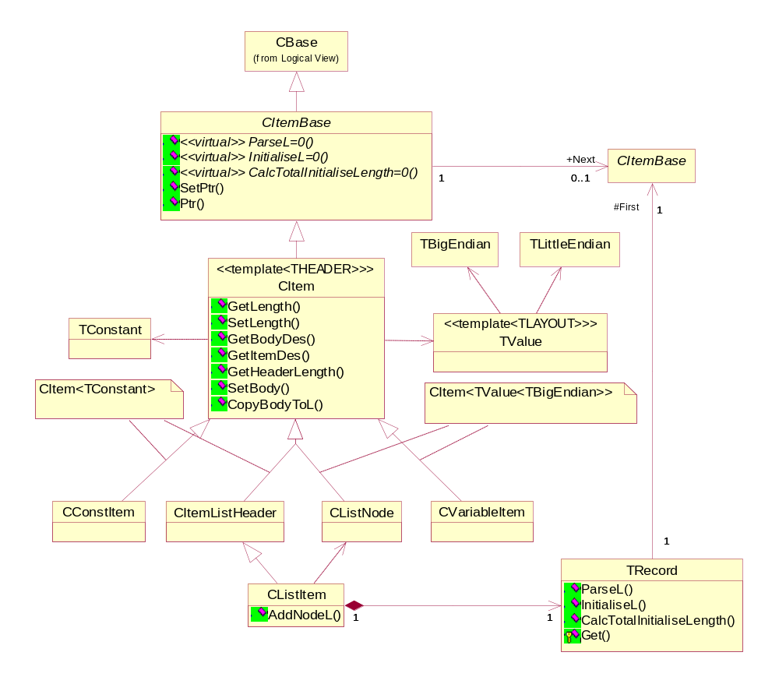
UML

Figure 3-2 The Message parser class layout and dependencies

Object name | Description | Associated (owned/dependant) objects
CItemBase | An abstract base for a record item. It provides abstract methods used by TRecord to parse/compose message record. | TUint8* a pointer to the beginning of the item’s part of the descriptor  CItemBase* a pointer to the next item in the record
CItem<THEADER> | A template to create an item having a header. The THEADER template parameter can be TValue or TConstant or any other user defined class following TValue class definition pattern. Such a class should not be bigger than 8 bytes. | THEADER the class representing the item’s header
CConstItem | A class representing an item of constant length
CVariableItem | A class representing an item of variable length
CListItemHeader | A header of dynamic part of the message
CListNode | One item in the dynamic list | It owns all items (nodes) it creates while parsing or that are added while composing the message
CListItem | The dynamic list having the structure given by Figure 3-3 | TRecord to point to the first item in the list and parse/initialise the list
TRecord | Applies the abstract functionality provided by CItemBase on the list of items. | CItemBase* a pointer to the first item in the list.
TValue<LAYOUT> | Represents a value. The template parameter LAYOUT can be TBigEndian or TLittleEndian or anything else which provides an interface given by either of these. | TInt the value length in bytes(octets)  TInt an initial value (used when composing a message)
TConstant | Represents a constant | TInt the value of the constant
TBigEndian | Represents a big endian byte layout
TLittleEndian | Represents a little endian byte layout

The classes related to the dynamic part of the message assume the following structure of the dynamic list:

Body
Header (Y bytes)

Dynamic part length (X bytes)
Item 1
Item 2
Item N

Maps to

Dynamic record

Figure 3-3 Dynamic record structure assumed by the design

For other types of message extensions it is necessary to define appropriate classes. Please refer to DHCP message option class COption for an example.

Behaviour
The following steps need to happen to parse a message record:
- Create an expected message class (see Figure 3-4 for some examples)
- Call theMsgClass.iRecord.ParseL( des8 )
- Access the class members (the message record items)

The following needs to happen on composition:
- Create an expected message class (see Figure 3-4 for some examples)
- Initialise each variable item length via theMsgClass.iItem.Header().SetInitialValue(itemLength)
- Create and add desired message extensions into the message list (via CListItem::AddNode() or CListItem::AddNodeL()) if any.
- Calculate the total length of a buffer to hold the data for the whole message via theMsgClass.iRecord.CalcTotalInitialiseLength()
- Allocate the buffer.
- Initialise the buffer via theMsgClass.iRecord.InitialiseL( hBuf8 )
- Access the class members (the message record items)

The following picture shows some examples of the message record declaration

class CHandshakeHeader : public CItem< TConstant >
{
public:
CHandshakeHeader( CItemBase* aNext ) :
CItem< TConstant >( aNext, KTlsHandshakeHeaderSize),
iRecord( this )
{
}

void ComposeHeader( ETlsHandshakeMessage aHandshakeMessage, TInt aLength );

public:
TRecord iRecord;
};

class CClientHelloMsg : public CHandshakeHeader
{
public:
CClientHelloMsg() :
CHandshakeHeader( &iVersion ),
iVersion( &iRandom, KTlsProtocolBodyLength ),
iRandom( &iSessionId ),
iSessionId( KTlsSessionIdLength, &iCipherSuite ),
iCipherSuite( KTlsCipherSuiteLength, &iCompression ),
iCompression( KTlsCompressionLength, NULL, KTlsCompressionBodyLength )
{
}
CConstItem iVersion; // SSL or TLS protocol version, 2 bytes
CRandomItem iRandom; // 32 byte Random value
CVariableItem iSessionId; // Session Id (variable size, 32 bytes or less)
CVariableItem iCipherSuite; // Proposed cipher suites (variable size)
CVariableItem iCompression; // Proposed compression methods (variable size)
};

class CCertificateMsg : public CHandshakeHeader
{
public:
CCertificateMsg() :
CHandshakeHeader( &iCertificateList ),
iCertificateList( 0, KTlsCertChainLength )
{
}

CListItem iCertificateList; // List of certificates (Certificate chain)
};
Figure 3-4 Examples of message record declaration
After the message record’s instance has been initialised, either by TRecord::ParseL (on input) or TRecord::InitaliseL (on output), we can access items in a record payload as they arrive and copy just these we need to save for later. The items can be constructed directly to the record payload with no need to allocate intermittent descriptor. We are also taking advantage of the OS exceptions whilst parsing/composing the payload.

Design Considerations
If we look at the section 3.2 and see what needs to happen on message composition it looks like a rather lot of steps. On the other hand, these steps need to happen anyway somewhere. Somehow, we need to know the items’ length before we can allocate a buffer and so on. There is a possibility to hide the total buffer length computation and the buffer allocation under the single call InitialiseL( HBufC8*& ). Having initialised all variable items’ length, the function can go off and keep reallocating its parameter. However, there is a performance issue since it is quicker to allocate a buffer at once than several times. In any case the functionality can be easily added in the future, in form of new virtual function InitialiseL( HBufC8*& ), if the element proves useful and will be actually used.

People
Role | Person / People
Contributor(s) | Kevin Benton
Reviewer(s)

References
No. | Document Reference | Version | Description
[1] | Message Structure Design |  | UML model
[2] | DHCP code |  | Element usage example
[3] | TLS code |  | Element usage example

Open Issues
The following issues need to be resolved before this document is completed:
- How to make it work with non-continuous descriptors (e.g. MBufChain)

Glossary
The following technical terms and abbreviations are used within this document.
Term | Definition

Document History
Date | Version | Status | Description
07-04-2003 | 0.1 | Draft | First draft
06-02-2004 | 1.0 | Issued | Updated and issued after review

Document Review Date

